Anthony Cunningham

Experimental Design & Analysis

4/4/18

**Homework 7 R Code and Output**

1)

light <- read.table("http://www.stat.uiowa.edu/~ernli/DOEdata/problem0515.txt", header=TRUE)

with(light, interaction.plot(Temperature, Glass, Light, type="b"))



lightLM = lm(Light ~ factor(Glass)*factor(Temperature), light)

summary(aov(lightLM))

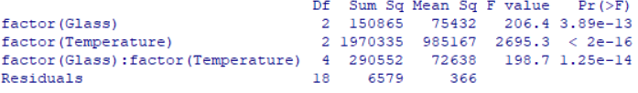

lightQuad = lm(Light ~ factor(Glass)*(Temperature + I(Temperature^2)), light)

summary(aov(lightQuad))

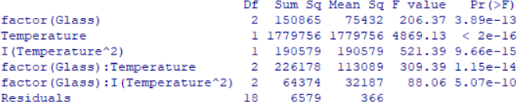

ngrid = 20

tg = with(light, seq(min(Temperature), max(Temperature), length = ngrid))

grid = expand.grid(Temperature = tg, Glass = levels(factor(light$Glass)))

y.hat <- predict(lightQuad, grid)

y.hat <- matrix(y.hat, nrow = length(tg))

matplot(tg, y.hat, type = "l", xlab = "Temperature", lwd=3)

abline(v = c(100, 125, 150), lty = 2)

legend("topleft", legend = paste("Glass Type", levels(factor(light$Glass))), lty = 1:3, col = 1:3, lwd=3)



2)

(current <- read.table("http://www.stat.uiowa.edu/~ernli/DOEdata/problem0530.txt", header=TRUE))

with(current, interaction.plot(Temperature, Doping, Current, type="b"))



currentLM = lm(Current~factor(Doping)*factor(Temperature), current)

summary(aov(currentLM))

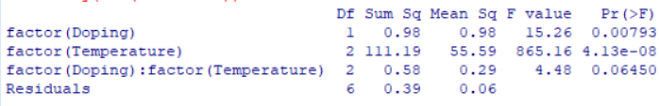

currentQLM = lm(Current~Doping + Temperature + Doping:Temperature, current)

summary(currentQLM)

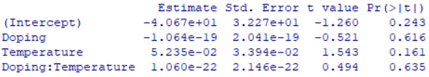

currentLackofFit = lm(Current~Doping + Temperature + Doping:Temperature + factor(Doping):factor(Temperature), current)

summary(aov(currentLackofFit))

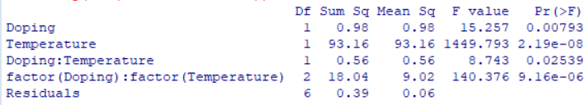

currentFullLM = lm(Current~Doping*(Temperature + I(Temperature^2)), current)

summary(aov(currentFullLM))

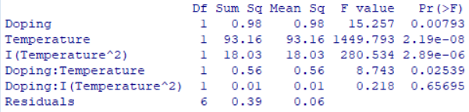

summary(currentFullLM)

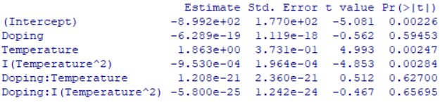

persp(currentFullLM, Doping~Temperature)



contour(currentFullLM, Doping~Temperature)



3)

(vibration <- read.table("http://www.stat.uiowa.edu/~ernli/DOEdata/problem0609.txt", header=TRUE))

vibrationLM = lm(Vibration~Bit*Speed, vibration)

summary(aov(vibrationLM))

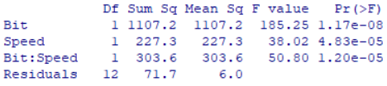

with(vibration, interaction.plot(Speed, Bit, Vibration, type="b"))



attach(vibration)

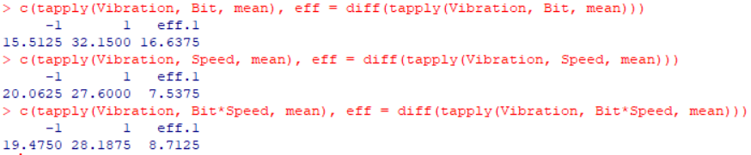

summary(vibrationLM)

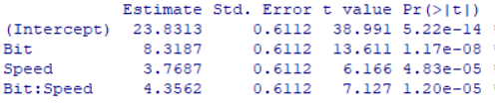

persp(vibrationLM, Bit~Speed)



contour(vibrationLM, Bit~Speed)

